
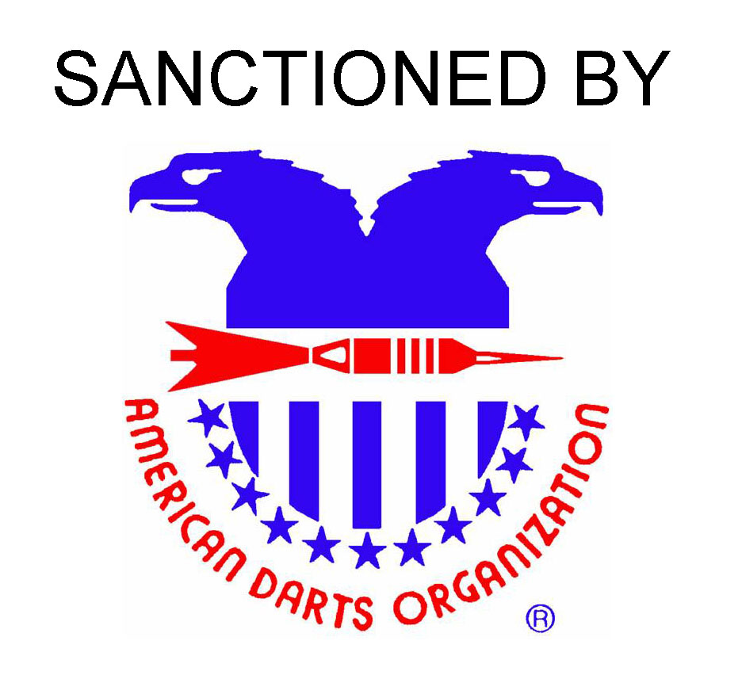
The Juneau Dart Association presents

The 20th Annual
Sister City
Dart Classic
Minimum $5000+ payout
February 18th – 20th 2010
Squire’s Rest in Auke Bay, Alaska

Registration closes 15 minutes prior to each Event’s start times!
Time | Friday  2/19  7 pm | Saturday  2/20  10 am | Saturday  2/20  2 pm | Saturday  2/20  2:30 pm | Saturday  2/20  6:30 pm | Saturday  2/20  7:00pm | Sunday  2/21  10 am | Sunday  2/21  10:30 am
Event | Blind Draw  Doubles  ‘01  SO/DO | Mixed  Doubles  ‘01  SO/DO | Women’s  Singles  Cricket | Men’s  Singles  Cricket | Women’s  Doubles  ‘01  SO/DO | Men’s Doubles  ‘01  SO/DO | Women’s  Singles  ‘01  SO/DO | Men’s  Singles  ‘01  SO/DO
Fee | $26/team | $26/team | *$15 | *$15 | $26/team | $26/team | *$15 | *$15
1st | $300 | $250 | $200 | $250 | $250 | $300 | $250 | $300
2nd | $150 | $130 | $100 | $125 | $130 | $150 | $125 | $150
3rd/4th | $80 | $70 | $50 | $70 | $70 | $80 | $65 | $75
5th-8th | $40 | $20 | $20 | $20 | $30 | $30 | $20 | $20
* Includes a $2 ADO Fee

ADO
Team Regional
Friday 12 pm
February 18th
@ Squires Rest

Hotel Information:
Juneau Airport Travelodge
$ Not Available Yet
Double Occupancy
Request: Alaska Rate
1-866-660-2327
For more information contact:

Phil Wheeler 907-209-5411 ptmpwheeler@gmail.com

Ted Quinn 907-780-3725 tquinn@capital-office.com

